CURRICULUM VITAE
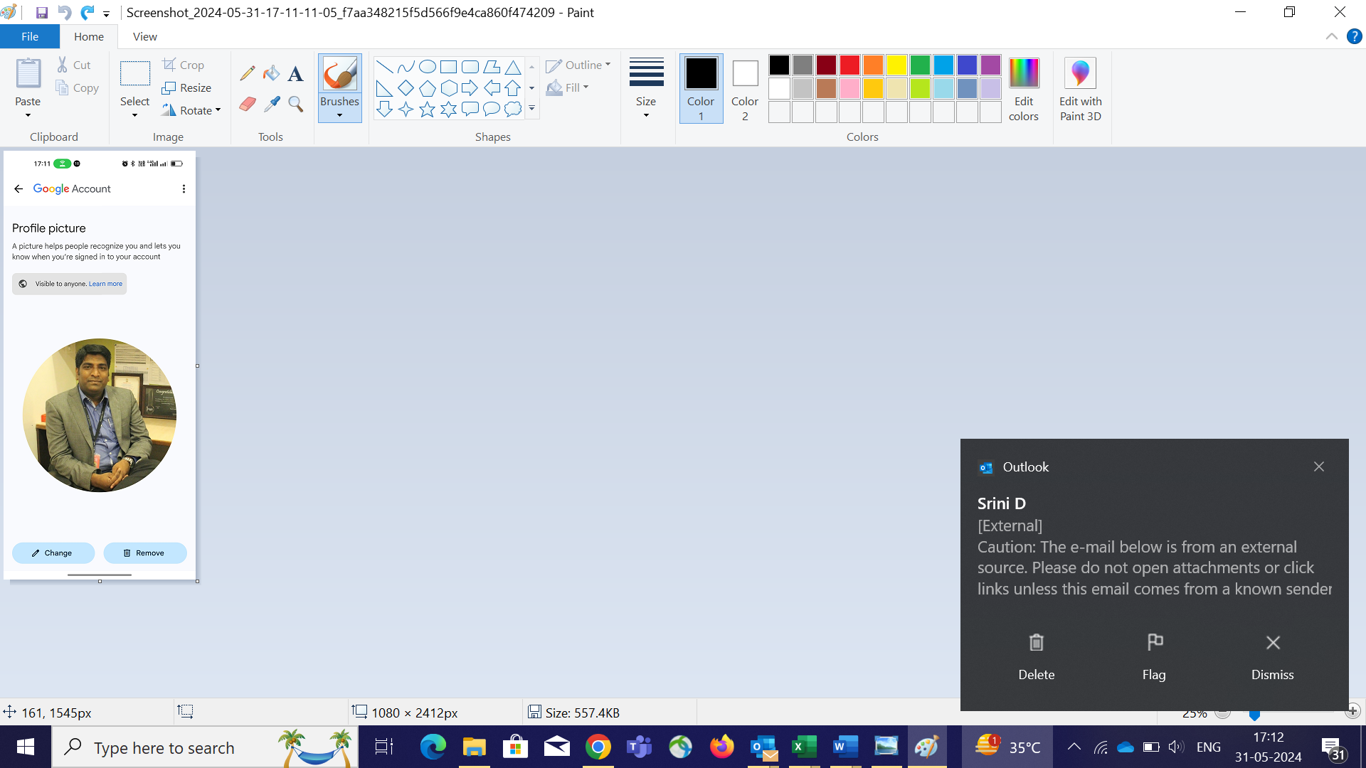

Srinivaslu- ( Srini)
Bangalore, Karnataka
Mobile:+919886767163
Email:Srini.d1900@gmail.com

Career Overview

A competent professional with Over all 22.8 years of experience in the Retail Operation with Multiple organization (Landmark Group /Raheja Group/Aditiya Birla/Future Group /Reliance Retail).
Organization | Role | Period | City - Region
Reliance- Yousta | South - Operation Manager | Sep 2022 to Till Now | Bangalore - IBC
Reliance- Trends | Chief Manager – Trends | Dec 2017 to Sep 2022 | Bangalore - Richmond Head Office
Pantaloons | Area Business Manager | Oct 2015 to Nov 2017 | Koramangala - Bangalore
Shoppers Stop | Retail Operation Manager | Nov 2011 to Oct 2015 | Bangalore
Lifestyle | Concept Manager & Store Manager | Nov 2006 to Feb 2011 | Begumpet - Hyderabad
Central/Big Bazaar | Assistant Dept Manager | June 2005 to Nov 2006 | Abids/Punjagutta- Hyderabad
Shoppers Stop | Customer Care Associate | April 2002 to June 2005 | Begumpet - Hyderabad

Core Competencies
- Launching New Format with Positive EBIDTA.
- Identifying New Catchment for Business.
- Business – Strategy for Future Growth and Market Share.
- NSO – New Store - Property finalizing & Setting up the Store and launch Store .
- Defining SOP – As per the New business requirement.
- Analyzing the Competition on Merchandise/Prize points /Design & Marketing.
- Statistic plan to improve Sale & SPSF Growth.
- Ensuring the NSO Store Delivery the Desire Sale no to meet the payback period.
- Major Focus on Weekly Launch and New Drop sell thru 90%
- Hight Sell Thru to reduce Reverse logistics & D&L /Ajio Margin to ach Bottom Line.
- Marketing Plan to increase the FF & Repeat Customer thru, Merchandise /VM/Customer Service/ NPS.
- Annual Operational Plan to Ach SPSF & Sale Target.
- Finding opportunity for Internal Growth of business.
- AOP sale budget plan & Achievement with Driving Promotion according to Market.
- Leadership skills & People development.
- Strong at analytical skill to ensure Sale Target Projection & achieved.
- Forecasting the Sale & Ach Yearly plan.
- Developing periodic business plans & strategies, in coordination with organization.
- Planning self and team short term & long term Goal plan for the professional growth.
EDUCATIONAL PROFILE
* B.A from A.V.COLLEGE OF ART & SCIENCE, Osmania University, HYDERABAD.
* Intermediate from ST. MARY JUNIOR COLLAGE, SECUNDERABAD.
* S.S.C. from K.V.NO.1 (C.B.S.E), AFA HYDERABAD.
IT SKILLS
* Diploma in computer application (D.C.A) SISI-CMTS, SECUNDERABAD.

* SAP – Certification Course.

WORK EXPERIENCE

South – Operational Head ( 5 State-KL/KA/AP/TG/TN)

Yousta – South Ops Head – Handling the store Operation of south, Part of New Format launch – Opened 20 Store in 1 yrs.
Delivering 657 SPSF with 12% EBIDTA.
Managing 115000 Sqft
Part of New format launch from Sep 2023.
Bangalore – IBC.

Chief Manager – Trends F&L Format
Reliance Retail Pvt Ltd.
Bangalore - IBC

Worked as Chief Manager (Area Manager) with Reliance Retail (Trends Division) from Dec 2017 Till Sep 2022.
- Handling 2.4 lakh Sft.( Annual Turn Around – 252.00Cr)
- 22% Sale contribution towards the region.
- Rs: 1080 SPSF as Cluster.
- Handling 19 Store which including (Bangalore & Rest Of Karnataka).
- Opened 6 NSO store in Bangalore/ROKN.
- Part of Software development for Store Operation.
- Part of New Project Called (Operation Center).
- Part of New SOP process.
- Panel member of Store Manager/Department Manager assessment
- EBITA of 19%
Worked as Area Business Manager in Aditya Birla Group (Pantaloons Division) Since Oct 2015 to Nov 2017.
Bangalore – Kormangala Head office – South.

- Responsible for Day to day Store Operation & profitability to Company.
- Ensuring Customer loyalty Base increases at 30% Annually
- Ensuring Repeat Customer sale @ Store.
- Major-Focus on high profitability brands.
- Utilization of space and adding sale.
- Bottom line profitability to organization.
- Feedback to buyers /marketing/VM as per the current trend & customer behaviors.
- Analyzing the store performance & acting according to ensure.
- Analyzing market changes & sharing feedback to organization.

Worked as Retail Operational Manager in Shoppers stop Pvt ltd (Bannerghatta) From Feb 2011 to Oct 2015.(4.7yrs)
Bangalore – Bannerghatta
- Aching the Top line & bottom Line.
- Increase of pvt label sale to ach ebita.
- Focus on top ten departments for ach top line.
- Sale feedback is shared with merchandise to get the right stock on right time.
- Focused on high margin dept and sub dept .
- Regular audit to ensure to no deviation on sop.
- Increasing the loyalty base to get sale.
- Reducing operation expenses as much as possible & generating additional revenue to bottom line ( SOR/SOH).
- Completely responsible for store operations and customer service.

Lifestyle (Land Mark Group )
Worked as store manager at Begumpet- Hyderabad-AP, lifestyle for 4 year 2 month (Nov-2006 to Feb 2011). ( 4.8 Yrs) Begumpet – Hyderabad.
- Maintenance of store as per company SOP.
- Completely responsible for customer Service/Cashiers/Cash Dept/Inventory Dept/Customer Service Desk(TIC).
- Monitor control mechanisms for Cost and Shrinkage Control.
- Implementation of Marketing/VM plans and merchandising on the floor.
- Conduct of perpetual inventory of high value items.
- Inwards and Outward movement of the Stock.
- Coordinating in the sale and also in the promotions activities Achieving top line & bottom line during off sale.
- Achieving the top line of the sales in coordination with Concept Manager’s.
- Pre-planning of sale achieving budgets.
- Handling Day - to - Day operations of the store.
- Ensuring store Ambience as per company norms & satisfying the customers while listing their Queries & solving their Issues.

Big Bazaar (Future Group)
Abids - Hyderabad
Associated with the service Industry Pantaloon Groups (Big Bazaar) in the year June 2005 to Nov 2006. (1.4Yrs)
Worked as a Department Manager for non-apparels general merchandise.

- Monitor control mechanisms for Cost and Shrinkage Control.
- Coordinate with Internal, External and Stock Auditors with regard to stocks.

- Implementation of Marketing plans and merchandising on the floor.
- Conduct of perpetual inventory of high value items.
- Handling of Shop-in-shops in the store.
- Coordinating in the sale and also in the promotion’s activities.
- Handling of General Merchandising stocks and conducting mela in the store premises. And monitoring of sale and arranging the stocks of new range.

Shoppers Stop Pvt Ltd

Associated with Shoppers stop Pvt ltd at Hyderabad from the year April 2002 to June 2005 as Customer Care Representative.( 3.3Yrs)
Begumpet - Hyderabad

- Customer Service
- Maintaining the Dept as per the company norms
- Doing Visual merchandising in Dept.
- Enrolling the customer in loyalty program.
- Conducting Training to new Staff

Name : Srinivaslu.d
Date of Birth : 15th March 1982
Languages Known: English, Hindi, Kannada & Telugu

Mobile No : +919886767163
Notice Period: 30 Days.

